Chicago Masters Preview
Sideboard Staff
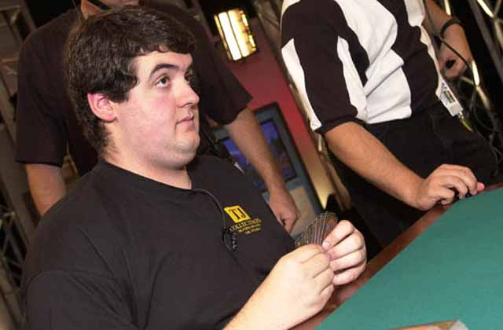
The field for the Masters Series event at Pro Tour Chicago is taking shape and it's a really great field. The Masters Series will pit 32 of the top players in the world in a single-elimination Invasion booster draft. Thirty of the prestigious invitations have been given away (and are included below). The final two spots will be given to the winners of a Gateway tournament to be held on Thursday, November 30th and open to anyone with 6 or more Pro Tour points in the New York '00-'01 professional standings. The Gateway will start with 3 or 4 rounds of Invasion sealed deck (depending on the number of competitors). Once the field has been narrowed to the "Sweet Sixteen," those players will be randomly divided into two tables for an Invasion booster draft where the winner of the table will win a Masters series invitation.
Here's the field:

Top 25 from New York Professional Standings:
Seeded Players:
1. Bob Maher
2. Jon Finkel
3. Alex Shvartsman
4. Ben Rubin
5. William Jensen
6. Darwin Kastle (wins ratings tiebreaker over Blackwell)
7. Trevor Blackwell
8. Gary Wise
9. Kyle Rose (wins ratings tiebreaker over Eskeland)
10. Sigurd Eskeland
11. Chris Benafel (wins ratings tiebreaker over Marsh)
12. Warren Marsh
13. Raphael Levy
14. Michael Turian (wins ratings tiebreaker over Valkyser)
15. Stephan Valkyser
16. Brian Davis
Unseeded:
Christian Luhrs
Ryan Fuller
David Williams
Thomas Preyer
Mike Bregoli
Satoshi Nakamura
Zvi Mowshowitz
Dan Clegg
Kai Budde

Top 5 from 10/23 DCI Limited Ratings:
#1 | John Ormerod | 2165
#2 | Mike Long | 2164
 | Darwin Kastle | 2163 already invited
#3 | Jakub Slemr | 2141
 | Trevor Blackwell | 2140 already invited
#4 | Igor Frayman | 2126
#5 | Joe Weber | 2124
Can "Baby Huey" win back to back Masters events? He is supposed to be better Limited player than Constructed player, after all. Can Jon Finkel break the $200,000 career earnings barrier? Who will survive the Gateway tournament? We'll find out the answers to all these question in Chicago on November 30-December 2. If you can't make it to the event yourself, stay tuned to the Sideboard for live coverage all weekend long.

